COMMUNITY CONCERNS
Sis. Lesa Lee | †Sis. Destiny Hill

† INTROIT – “Kum Ba Yah My Lord”

THE CALL TO WORSHIP Rev. Denise Wynn | † Rev. Lucy Grain

P: This is the day the Lord has made !
L: We come rejoicing and giving thanks.
P: This is the day God invites us to love and to live.
L: We seek to dwell in God’s love as we turn our hearts toward God.
P: This is the day to worship our creator and redeemer
ALL: We worship the God of life.

INVOCATION

HYMN OF CELEBRATION #441 ”Standing In The Need Of Prayer”

RESPONSIVE READING #84 ” Racial Reconciliation”

GLORIA PATRI - Meineke 652

DIACONATE PRAYER Dea. Lillian Stringfield | † Dea. Millie Dixon

CHANT “Hush, Somebody’s Calling My Name ”

THE CHURCH MISSION STATEMENT (IN UNISON)
We are the Body of Christ, the Church: teaching, preaching, and reaching
others for the Glory of God.

OFFERTORY SENTENCES (IN UNISON) & RECEPTION OF GIFTS
God provides abundantly for us and calls us to give generously to those in need. With gratitude for the blessings we have received, let us offer our gifts so that others may be blessed.

OFFERATORY PRAYER & DEDICATION
“All things Come of Thee” 668

BLACK HISTORY 365

SCRIPTURE LESSONS

Old Testament – Genesis 45: 5-8
Sis. Audrey Ward | † Sis. Angel Blythe
New Testament – Acts 17: 28-30
Sis. Karen Greene | † Bro. Gregory Wells

MEDITATION AND PASTORAL PRAYER

SERMONIC MUSIC
“How Deeply I Need You”
† ”Jesus Is Real”

Guest Speaker
Dr. Earl Caldwell – American Journalist
“An Eyewitness Account of the Assassination of Dr. MLK”

INVITATION TO COMMITMENT & CHRISTIAN DISCIPLESHIP

BENEDICTION

*****************************************************************************
THIS WEEK AT MAIN STREET

MON Budget Preview Session – 6:00 PM
TUE Usher Board Meeting 6:00 PM
Chosen Generation Rehearsal 7:00 PM
WED Good News @ Noon 12:00PM
Annual Church Business Session 7:00 PM
THUR Deacon Board Meeting – 7:00 PM

Nursing Duty: Sis. Loraine Jones | † Sis. Eunice Shears

HEALTH AFFAIRS UPDATE

- February is Heart Month. Learn the symptoms of heart attack and stroke and what to do if someone is showing the symptoms of having one. There is a card on Stroke and Heart Attack in the front and back lobby Take one of each to learn more about these conditions.
- Blood Pressure will be taken after each service on the first and second Sunday of each month.
- Wheelchair – We would like for someone to donate a wheelchair to the church. Please contact Barbara Davis or the office if you have one.

Black History Month February 2020 – See Insert

April 25, 26th 2020-Broadway, New York. Bus trip to see the Broadway Show “Ain’t Too Proud” sponsored by the Williams Mission Center Board. Please see any member of the WMC Board to reserve your seat.

ABCOTS 50TH JUBILEE-RICHMOND VA.-APRIL 27TH-30TH, 2020
EARLY REGISTRATION DEADLINE FEBRUARY 9, 2020. SEE REV. DENISE WYNN FOR REGISTRATION FORMS.

Schoolhouse Museum Scholarship Applications for high school seniors are available in the office.

Our Church Family: Monique Addison-Scott, Thomas Blount, John Burrell, Tracey Burrell, John Delk, Joan Elias, Johnsie Green, Bridgette Fields, Richard Linyear, Arleen Picott, Larry Pleasant, Melvin Raines, Fred Reid, Earline Scott, Dea. Milton Worthington, Bill Wiggins.

Extended Family: Rev. Easter Edwards, James Grandison, Dysheka Johnson, Rev. Wilbur R. Jones, Rufus Holliman, Ann Parker, Dorothy Parker, Rita Sessoms, Darlene Spady, Nettie Woodland, Sandra Johnson-Spencer

FAMILIES IN SORROW: Mamie Cone
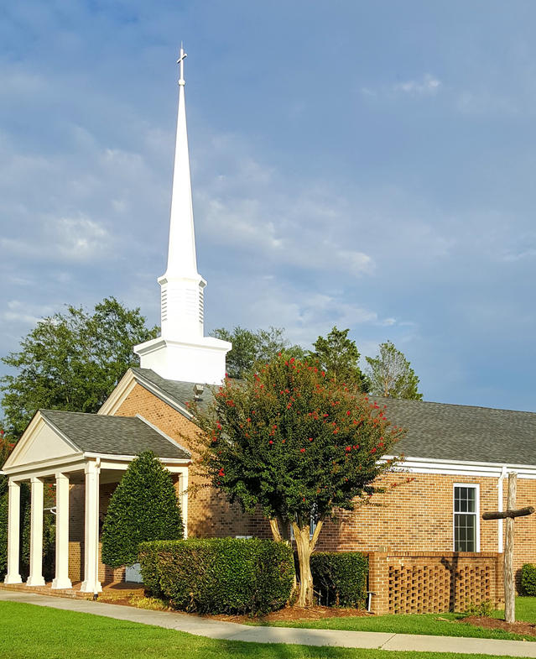

Main Street Baptist Church
February 9, 2020
517 Main Street | P.O. Box 159, Smithfield, VA 23431
757-357-2604 (v) | 757-357-9145 (f)
E-mail: mainstreetch@aol.com | Website: www.mainstreetbaptistva.org
James M. Harrison, D. Min., Pastor

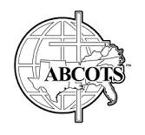
RECALLING, RECLAIMING, AND RENEWING IN CHRIST

