Sis. Lesa Lee | †Sis. Destiny Hill

† INTROIT – “Emmanuel”

THE CALL TO WORSHIP Rev. Denise Wynn | † Rev. Lucy Grain

L: People of the living God, come to the mountain of God.
P: Prepare the way of the Lord.
L: Sisters and brothers in Christ, prepare your hearts to hear the word of God.
P: Prepare the way of the Lord.
L: Children of the Holy Spirit, walk in the light of God.
P: Prepare the way of the Lord.
ALL: Come, Let us worship.

INVOCATION

HYMN OF THE PRAISE #202 “Go Tell It on the Mountain”

RESPONSIVE READING #36 “Patience” Old Testament

GLORIA PATRI - Meineke 652

DIACONATE PRAYER Dea. Millie Dixon | † Dea. Linda Woodson

ADVENT VOCAL MEDITATION
Sis. Sandra Smith

THE CHURCH MISSION STATEMENT (IN UNISON)
We are the Body of Christ, the Church: teaching, preaching, and reaching
others for the Glory of God.

OFFERTORY SENTENCES (IN UNISON) & RECEPTION OF GIFTS
May these gifts further God’s vision of a world of justice, righteousness, equity and prosperity the world over.

OFFERATORY PRAYER & DEDICATION
“All things Come of Thee” 668

BLACK HISTORY 365

SCRIPTURE LESSONS

Old Testament – Isaiah 9: 1-8
Bro. Al Judkins| † Sis. Loraine Jones
New Testament – Luke 1: 39-45
Bro. Thomas Spratley | † Dea. Johnnie Jones

MEDITATION AND PASTORAL PRAYER
SERMONIC MUSIC
“For Your Glory”
† “There Is No Christmas Time Without Jesus”

SERMON – Rev. James Harrison
“Attitudes of Advent”

INVITATION TO COMMITMENT & CHRISTIAN DISCIPLESHIP
BENEDICTION

*****************************************************************************
THIS WEEK AT MAIN STREET

MON Missionary Circle Meeting @ 6:00 PM
TUE Chosen Generation Rehearsal 7:00 PM
WED Good News @ Noon 12:00 PM
Religious Discussion 7:00 PM

Nursing Duty: Sis. Loraine Jones | † Sis. Eunice Shears

December 22, 2019- The MSBC Music and Youth Ministries will present a Christmas musical, “the Foretold Retold,” on Sunday, December 22, 2019 , at 6:00 PM in the Williams Mission Center. We look forward to our church, family, friends, and community support. To support this event, we will have a “Souvenir Booklet”. We are accepting ads and messages for this booklet. The prices are as follows:
- Full Page $75.00
- ½ Page $40.00
- ¼ Page $25.00
- 1/8 Page $15.00
Please see any member of the Music Ministry to submit your information. Deadline is December 12, 2019.

Save the Date- January 19, 2020- Please join the IOW NAACP 20th Annual Martin Luther King, Jr. Commemorative Banquet. The banquet will be at the Smithfield Center at 3:00 PM. Please see the bulletin board for information regarding tickets, table reservations, and the cost for ads. See Valerie Butler with any questions as well.

.

***************************************************************************************
Our Church Family: Monique Addison-Scott, Thomas Blount, John Burrell, Tracey Burrell, Mamie Cones, John Delk, Joan Elias, Johnsie Green, Bridgette Fields, Richard Linyear Larry Pleasant, Melvin Raines, Fred Reid, Earline Scott, Bill Wiggins, Eva Woolridge

Extended Family: Rev. Easter Edwards, James Grandison, Girlie Jones, Rev. Wilbur R. Jones, Rufus Holliman, Ann Parker, Dorothy Parker, Rita Sessoms, Darlene Spady, Nettie Woodland, Sandra Johnson-Spencer

FAMILIES IN SORROW: Sis Frances Delk, Philadelphia, PA, Loris Jones, Andrew Johnson

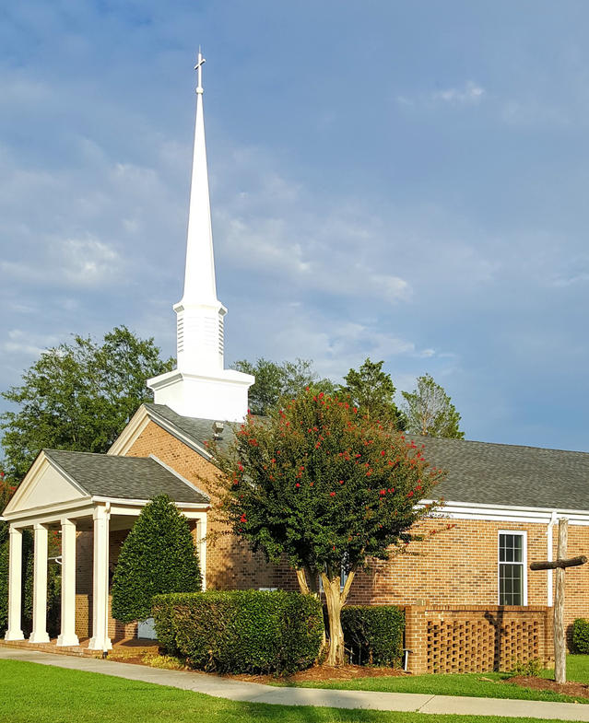

Main Street Baptist Church
December 8, 2019
517 Main Street | P.O. Box 159, Smithfield, VA 23431
757-357-2604 (v) | 757-357-9145 (f)
E-mail: mainstreetch@aol.com | Website: www.mainstreetbaptistva.org
James M. Harrison, D. Min., Pastor

RECALLING, RECLAIMING, AND RENEWING IN CHRIST

